Year 12 Chemistry Semester 1 Examination 2004 - Solutions

Part 1

1A, 2A, 3C, 4B, 5D, 6C, 7D, 8B, 9D, 10A, 11C, 12A, 13C, 14B, 15C, 16B, 17C, 18C, 19B, 20A, 21D, 22B, 23B, 24A, 25B, 26D, 27C, 28A, 29B, 30A

Part 2

- (a) (1)
White solid dissolves and system bubbles (2)

  - (1)

Solid dissolves. Colourless solution (2)

(c) (1)
Metal dissolves and a deep green solution is formed. The system also bubbles (2)

(d) (1)
Metal dissolves. Blue solution formed. Noxious gas created (2)

- (a) (i) (1)
(ii) (1)
(iii) (1)
(iv) (1)
(v) (1)
(b) W=8; X=3; Y=4; Z=9 (2)
(c) (1)
(d) pCl = -log[Cl⁻] = -log(0.01) = 2 (1)

- Natural gas and air do not react at room temperature because the particles do not have enough activation energy upon collision to satisfy the activation energy barrier (½). The piece of platinum is a catalyst. Hence, it provides a lower activation energy barrier for the reactant particles it comes into contact with (½). These particles therefore have enough energy to overcome the activation energy barrier and so react (½). This process releases heat energy as the reaction is exothermic (½). This heat energy speeds up other reactant molecules so that they achieve an energy that satisfies the energy barrier and react as well (½). A chain reaction begins where heat is expelled and used to allow other particles to react (½). The sum total of all exothermic reactions manifests itself as an explosion.

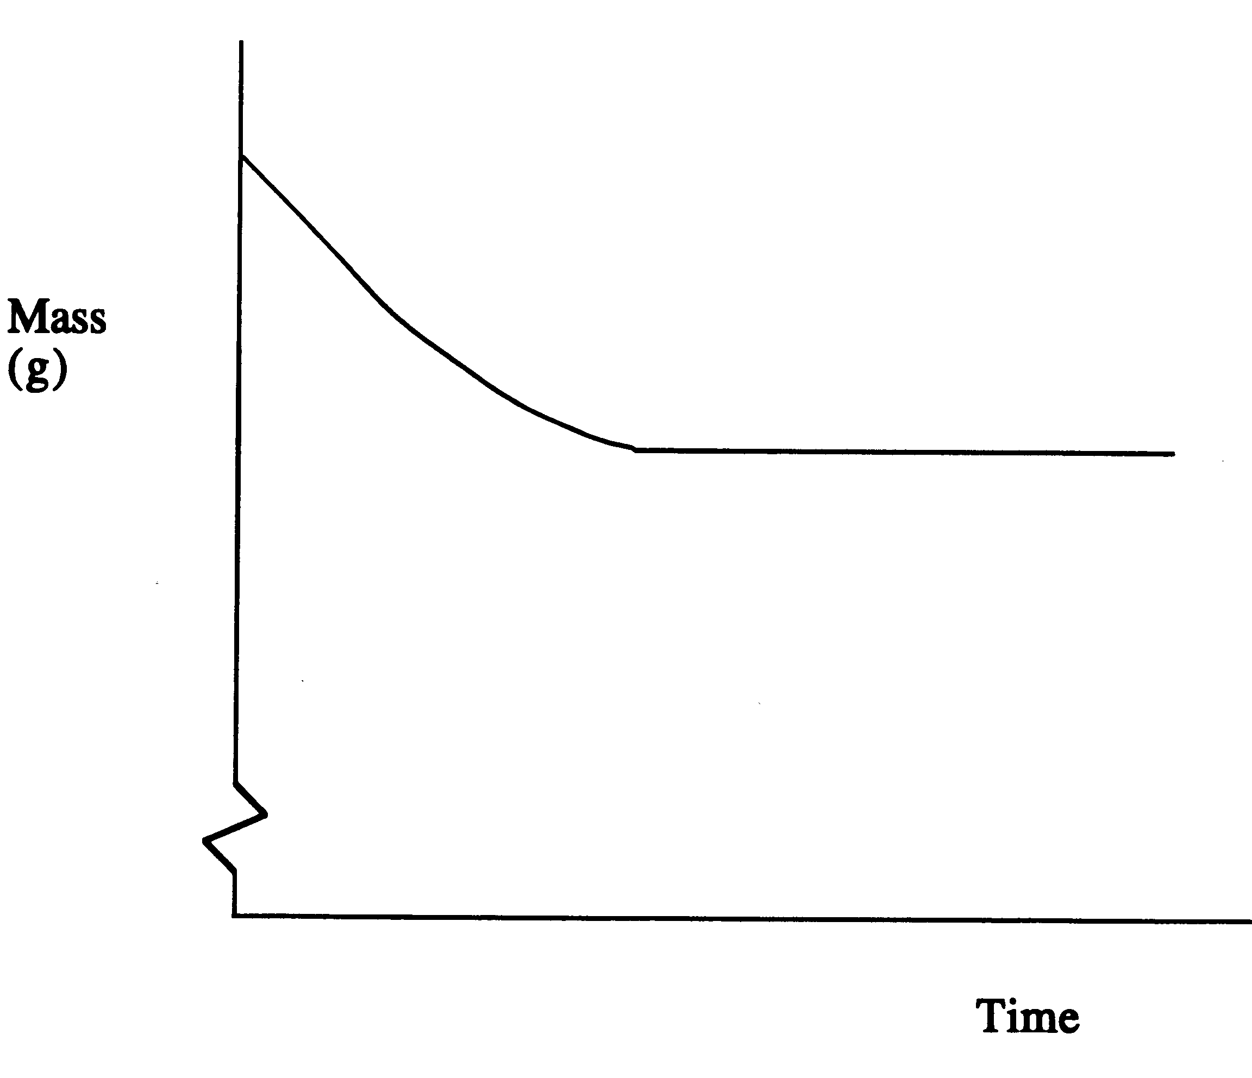
(1)
(a)

(b)

(1)

- The new concentration is lower than the original. As reaction rates increase with increased concentration of reagents, the new concentration ensures a lower rate. Hence, the gradient of the new curve is half as steep as the original. It will also take longer for the reaction to reach completion. Hence, the new curve reaches the horizontal further to the right (1).

- Ground-up copper offers more exposure to the acid. Hence, there are more successful collision and the reaction rate therefore increases. Hence, the gradient of the new curve is steeper thus requiring less time to reach completion. This is seen by the curve reaching the horizontal further to the left (1).

- (a) 350 kJ mol⁻¹ (1)

  - As the nitrogen dioxide and carbon monoxide molecules get closer to each other, the kinetic energy as a result of their movement is converted to potential energy as a result of their proximity to each other. (2)

- NO is the catalyst because it provides a convenient pathway for an oxygen atom of O₃ to break off and attach itself to a separate oxygen atom (1). Furthermore, like all catalysts NO participates in the reaction but is present at the end of the reaction as it was at the beginning of the reaction (1).

- (a) K = ([Cl₂]²[H₂O]²) / ([HCl]⁴[O₂]) (1)

  - The reaction is an exothermic reaction (½). If it is at equilibrium at 450ºC and suddenly heat is inputted to cause a rise in temperature to 550ºC, the system according to Le Châtelier’s Principle will try to oppose the change in order to re-establish equilibrium (1). Hence, the endothermic reaction will prevail and the equilibrium will push to the left (½). As this will increase the quantities of reactants, the new equilibrium constant (at 550ºC) will be smaller than the original 450ºC equilibrium constant (1).

  - If the pressure of the system is decreased by expanding the volume at constant temperature then the system according to Le Châtelier’s Principle will try to oppose the change in order to re-establish equilibrium (1). Hence, an increase in particle concentration will attempt to take place. As we move from right to left in the reaction, 4 gas particles produces 5 gas particles (1). As this is an increase in gas particles this reaction will prevail and the equilibrium will push to the left (½). Hence, re-establishment of equilibrium decreases the product concentrations and increases the reactant concentrations (½).

  - No change in K (1).

  - The colour of the system. Bromine gas is reddish brown. The more the equilibrium lies to the right, the greater the intensity of the reddish brown colour (1).

  - The rate of the forward and reverse reactions as well as the macroscopic properties of the system (2).

+6 -2 -3 +1 0 +3 (2)

(1)

2 x [ ] (2)
(2)

(2)
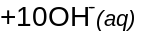
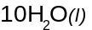
2
(3)

- (a) Hypochlorous acid is able to destroy algae and bacteria because it causes the oxidation of these organisms which in turn kills the organisms (1). The difference between HClO and ClO⁻ is the speed at which they cause oxidation. Hypochlorous acid is more effective because it tends to be reduced much more quickly than hypochlorite ion (1).

  - Coke, Iron Ore & Limestone (3)

  - 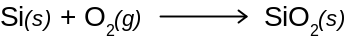 (1)

- (a) (2)

(b) Dissolve solid in hot water (1); boil for 10 minutes (1); cover and cool (1); filter through a sintered glass crucible (2); and store in a dark bottle (1).

Part 3

Question 1

Take 1 L of the gas.

n(NO₂) = PV/RT = (101.3 x 1)/(8.3145 x 308) = 3.96 x 10⁻² mol (1)

m(NO₂) = n x M = (3.96 x 10⁻²) x 46.0055 = 1.82 g (1)

density(NO₂) = m(NO₂)/V = 1.82/1 = 1.82 gL⁻¹ (1)

Question 2

Let’s take 1 L of solution.
Hence, n(HNO₃) = 16.0 (1)
m(HNO₃) = n x M = 16.0 x 63.0128 = 1008.2048 (1)
%(HNO₃) = [m(HNO₃) / m(solution)] x 100
70 = [1008.2048 / m(solution)] x 100
m(solution) = 1440.29 g (1)
density(solution) = m(solution)/V = 1440.29 g / 1 L = 1440 gL⁻¹ = 1.44 g/mL (1)

Question 3

n(CO₂) = PV/RT = (154.2 x 3.72)/(8.3145 x 300) = 0.2300 mol (1)
n(Na) = m/M = 4.52 / 22.9897 = 0.1970 mol (1)

How many moles of Na is needed to consume all the CO₂?
n(Na) = 4 x [n(CO₂)/3] = 4 x [0.2300 / 3] = 0.3066. We only have 0.2300. Hence, sodium is the limiting reagent (1).

n(Na₂CO₃) = 0.5 x n(Na) =0.5 x 0.1970 = 0.0983 mol (1/2)
m(Na₂CO₃) = n x M = 0.0983 x 105.988 = 10.4 g (1/2)
n(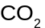)_{used} =(3/4) x n(Na) = (3/4) x 0.3066 = 0.147 (1)
n()_{remaining} = n()_{start} - n()_{used} = 0.2300 - 0.147 = 0.0825 mol (1)

Question 4

A particular ore contains 47.2% MnO₂. What mass of the ore must be refined to produce 2.50 tonnes of pure manganese metal?

%(Mn) = [M(Mn)/M(MnO₂)] x 100 = (54.9380/86.9368) x 100 = 63.19 (1)

n(Mn) = m/M = (2.50 x 10⁶)/54.9380 = 4.55 x 10⁴ (1)

n(MnO₂) = n(Mn) = 4.55 x 10⁴ (1)

m(MnO₂) = n x M = (4.55 x 10⁴) x 86.9368 = 3.96 x 10⁶ g (1)

%(MnO₂) = [m(MnO₂)/m(ore)] x 100

47.2 = [(3.96 x 10⁶)/m(ore)] x 100 (1)

m(ore) = 8.38 x 10⁶ g = 8.38 tonnes (1)

Question 5

(a) n(CeO₂) = m/M = 2.312/172.1147 = 1.343 x 10⁻² moles (1)
n(Ce(IV)) = n(CeO₂) = 1.343 x 10⁻² moles (1)

This Ce(IV) comes from the Ce(III) and Ce(IV) in the original mass of sample before oxidation of Ce(III).

Hence, n(Ce(III) + Ce(IV)) in 2.167 g sample = 1.343 x 10⁻² moles

m(Ce(III) + Ce(IV)) in 2.167 g sample = n x M = (1.343 x 10⁻²) x 140.1159
= 1.882 g (1)

In 1.528 g sample, n(NO₃⁻) = m/M = 0.5230/62.0049 = 8.435 x 10⁻³ mol (1)
3 mol of NO₃⁻ are found in 1 mole of Ce(NO₃)₃
Therfore n(Ce(NO₃)₃) = n(NO₃⁻)/3 = (8.435 x 10⁻³)/ 3 = 2.812 x 10⁻³ (1)
n(Ce(III)) = n(Ce(NO₃)₃) = 2.812 x 10⁻³ (1)
m(Ce(III)) = n x M = (2.812 x 10⁻³ ) x 140.1159 = 0.3940 g (1)
%(Ce(III)) = [m(Ce(III))/m(sample)] x 100 = [0.3940/1.528] x 100 = 25.8% (1)

In 2.167 g of sample, m(Ce(III)) = (25.8/100) x 2.167 = 0.5587 g (1)
In 2.167 g of sample, m(Ce(III) + Ce(IV)) = 1.882 g

Therefore m(Ce(IV)) in 2.167 g sample = 1.882 – 0.5587 = 1.323 g (1)

%(Ce(IV)) = [m(Ce(IV))/m(sample)] x 100 = [1.323/2.167] x 100 = 61.1 % (1)

(b) n(I₂) = 2 x n(CeO₂) = (2 x 1.343 x 10⁻²) = 2.687 x 10⁻² moles (1)

p(I₂) = (nRT)/V = [(2.687 x 10⁻²) x 8.31451 x 298] / 0.2554 = 261 kPa (1)

Question 6

N converted to

NH₃

NaOH
V = 5.90 ml
c = 1.028 mol L⁻¹

HCl
V = 50.0 ml
c = 0.1970 mol L⁻¹

Dried Protein
m = 0.895 g

Unreacted HCl

n(NaOH) = c x V = 1.028 x 0.00590 = 6.065 x 10⁻³ mol (1)

(1)

n(unreacted HCl) = n(NaOH) = 6.065 x 10⁻³ mol (1)

n(HCl before reaction) = c x V = 0.1970 x 0.050 = 9.850 x 10⁻³ mol (1)

n(HCl reacting with NH₃) = n(HCl before reaction) - n(unreacted HCl)
= (9.850 x 10⁻³) – (6.065 x 10⁻³)
= 3.785 x 10⁻³ mol (1)

(1)

n(NH₃) = n(HCl) = 3.785 x 10⁻³ mol (1)

n(N in protein) = n(NH₃) = 3.785 x 10⁻³ mol (1)

m(N in protein) = n x M = (3.785 x 10⁻³) x 14.01 = 0.0530 g (1)

%(N) = [m(N in protein) / m(protein)] x 100 = [0.0530 / 0.895] x 100 = 5.92% (1)

Question 7

FeSO₄
V = 50 mL
c = 0.0931 mol L⁻¹

K₂S₂O₈
A

500 mL
E
KMnO₄
c = 0.0194 mol L⁻¹
V = 21.08 ml
D
50 mL
25 mL
C

B

n(Fe²⁺)_{A} = c x V = 0.0931 x 0.050 = 4.655 x 10⁻³ mol (1)

n(MnO₄⁻) = n(KMnO₄) = c x V = 0.0194 x 0.02108 = 4.090 x 10⁻⁴ mol (1)

n(Fe²⁺)_{B} = 5 x n(MnO₄⁻) = (5 x 4.090 x 10⁻⁴) = 2.045 x 10⁻³ mol (1)

n(Fe²⁺)_{reacting with persulfate} = n(Fe²⁺)_{A} - n(Fe²⁺)_{B} = (4.655 x 10⁻³) – (2.045 x 10⁻³)
= 2.610 x 10⁻³ mol (1)

n(K₂S₂O₈)_{C} = n(S₂O₈²⁻)_{C} = n(Fe²⁺)_{reacting with persulfate} / 2
= (2.610 x 10⁻³) / 2
= 1.3051 x 10⁻³ mol (1)

c(K₂S₂O₈)_{D} = c(K₂S₂O₈)_{C} = n(K₂S₂O₈)_{C} / V =
= (1.3051 x 10⁻³)/0.025
= 5.220 x 10⁻² mol L⁻¹ (1)

n(K₂S₂O₈)_{D} = c(K₂S₂O₈)_{D} x V = (5.220 x 10⁻²) x 0.5 = 2.610 x 10⁻² mol L⁻¹ (1)

c(K₂S₂O₈)_{E} = n(K₂S₂O₈)_{D} / 0.05 = 0.522 mol L⁻¹ (1)

Part 4

Question 1

Process | General Points | Details
Haber and Contact | Reaction rate Requirements | High Pressures (1) and explanation in terms of collision theory. (2)
Haber and Contact | Reaction rate Requirements | High temperatures (1) and explanation in terms of collision theory. (2)
Haber and Contact | Reaction rate Requirements | Catalysts (1) and explanation in terms of collision theory. (2)
Haber | Correct Equation | (2)
Haber | Equilibrium Requirements | Low temperatures (1) and explanation in terms of Le Châtelier’s Principle. (2)
Haber | Equilibrium Requirements | High pressures (1) and explanation in terms of Le Châtelier’s Principle. (2)
Haber | Economic Requirements | Low temperatures are cheaper. (1)
Haber | Economic Requirements | Low pressures are cheaper. (1)
Haber | The Compromise | Iron/iron oxide catalyst (1) allows lower temperatures of about 500ºC (1). This satisfies the reaction rate and equilibrium needs. (1)
Haber | The Compromise | High pressures of 350 atm used (1). This satisfies the reaction rate and equilibrium requirements(2), but works against the economic requirement (1).
Contact | Equations | 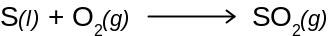 (1)  (2)  (1)  (1)
Contact | Equilibrium Requirements | Low temperatures (1) and explanation in terms of Le Châtelier’s Principle. (2)
Contact | Equilibrium Requirements | High pressures (1) and explanation in terms of Le Châtelier’s Principle. (2)
Contact | Equilibrium Requirements | Excess Air (1) and explanation in terms of Le Châtelier’s Principle. (2)
Contact | Economic Requirements | Low temperatures are cheaper. (marks already allocated)
Contact | Economic Requirements | Low pressures are cheaper. (marks already allocated)
Contact | The Compromise | High pressures not used because the costs are too high (1)
Contact | The Compromise | V₂O₅ catalyst (1) allows lower temperatures of about 400ºC (1).
Contact | The Compromise | This satisfies the reaction rate and equilibrium needs. (1)

Chemical Content: 44
Coherence and Clarity of Expression: 6

/50 Multiple by 0.4 to make /20

Question 2

Step | General Points | Details
Preparation of Na₂CO₃ | Dry Na₂CO₃ | Water absorbed onto Na₂CO₃ is a source of error. (1)
Preparation of Na₂CO₃ | Dry Na₂CO₃ | Heat Na₂CO₃ in oven at 270ºC for 30 minutes. (1)
Preparation of Na₂CO₃ | Dry Na₂CO₃ | Cool in desiccator. (1)
Preparation of Na₂CO₃ | Weigh Na₂CO₃ and transfer to volumetric flask | Add approximately 2.65 g into a dry beaker. (1)
Preparation of Na₂CO₃ | Weigh Na₂CO₃ and transfer to volumetric flask | Weigh accurately the container and Na₂CO₃ (1)
Preparation of Na₂CO₃ | Weigh Na₂CO₃ and transfer to volumetric flask | Transfer solid to 500 ml volumetric flask (1) that has been rinsed out with distilled water (1)
Preparation of Na₂CO₃ | Weigh Na₂CO₃ and transfer to volumetric flask | Weigh accurately the beaker. (1) Subtracting the 2 weights gives the exact mass of solid. This prevents the error caused by solid sticking to the beaker but being thought to exist in the volumetric flask. (1)
Preparation of Na₂CO₃ | Dissolve Na₂CO₃ and add water. | Add small amounts of water to the volumetric flask and shake to dissolve all the solid. (1)
Preparation of Na₂CO₃ | Dissolve Na₂CO₃ and add water. | A source of error is adding too much water before all solid is dissolved. (1)
Preparation of Na₂CO₃ | Dissolve Na₂CO₃ and add water. | Also shaking volumetric might cause liquid to splash. (1)
Preparation of Na₂CO₃ | Dissolve Na₂CO₃ and add water. | Once dissolved, add water to the mark and invert several times. (1)
Preparation of Na₂CO₃ | Dissolve Na₂CO₃ and add water. | Source of error: over-stepping or under-stepping the mark as a result of parallax error and user technique. (1)
Preparation of HCl | Concentrated HCl to volumetric flask and dilution | Measure approximately 5 ml of concentrated HCl. Add this HCl to some water in a 500 ml volumetric flask and make up to the mark with water. (1)
Standardisation of HCl  Preparation of NaOH | Use of pipette, burette and indicators | Rinse burette out with the HCl solution. (1)
Standardisation of HCl  Preparation of NaOH | Use of pipette, burette and indicators | If the burette is cleaned with distilled water, the HCl will change concentration when it is added to the burette as a result of the remaining water in the burette (very difficult to completely dry the burette) (1)
Standardisation of HCl  Preparation of NaOH | Use of pipette, burette and indicators | Open tap to allow flow and the removal of air bubbles. (1)
Standardisation of HCl  Preparation of NaOH | Use of pipette, burette and indicators | Accurately read to 2 decimal places the initial volume of the acid in the burette. (1)
Standardisation of HCl  Preparation of NaOH | Use of pipette, burette and indicators | Source of error: parallax error. (1) Hence, read at eye level (1)
Standardisation of HCl  Preparation of NaOH | Use of pipette, burette and indicators | Clean out pipette with Na₂CO₃ solution. (1)
Standardisation of HCl  Preparation of NaOH | Use of pipette, burette and indicators | If the pipette is cleaned with distilled water, the Na₂CO₃ will change concentration when it is added to the burette as a result of the remaining water in the pipette (very difficult to completely dry the pipette) (1)
Standardisation of HCl  Preparation of NaOH | Use of pipette, burette and indicators | Pipette 20 ml of Na₂CO₃ into a conical flask that has bee cleaned with water. (1)
Standardisation of HCl  Preparation of NaOH | Use of pipette, burette and indicators | Add a drop or 2 of methyl orange. (1) This indicator changes in the acidic range. (1)
Standardisation of HCl  Preparation of NaOH | Use of pipette, burette and indicators | This is necessary because the carbon dioxide produced at neutralisation reacts with water to produce carbonic acid which makes the solution slightly acidic. (1)
Standardisation of HCl  Preparation of NaOH | Use of pipette, burette and indicators | Titrate to the first permanent change in colour. (1)
Standardisation of HCl  Preparation of NaOH | Use of pipette, burette and indicators | Accurately read to 2 decimal places the final volume of the acid in the burette. (1)
Standardisation of HCl  Preparation of NaOH | Use of pipette, burette and indicators | Subtract the initial volume from the final volume to determine the titre. (1)
Standardisation of HCl  Preparation of NaOH | Use of pipette, burette and indicators | Source of error: overstepping the end-point. (1) This is avoided by doing a rough titration so that at subsequent titrations the approximately volume is known allowing a 1 drop colour change to occur. (1)
Standardisation of HCl  Preparation of NaOH | Use of pipette, burette and indicators | To minimise user error, do at least 3 accurate titrations. (1)
Standardisation of HCl  Preparation of NaOH | Use of pipette, burette and indicators | Average titres that are close to each other (+- 0.02 ml) (1)
Standardisation of HCl  Preparation of NaOH | Use of pipette, burette and indicators | Sketch of Titration Curve (1)
Standardisation of HCl  Preparation of NaOH | Use of pipette, burette and indicators | Reaction (1)
Standardisation of HCl  Preparation of NaOH | Use of pipette, burette and indicators | Calculate the concentration of HCl (1)
Standardisation of HCl  Preparation of NaOH | Solid NaOH to volumetric flask, dissolution and dilution. | Add quickly approximately 2.0 g of NaOH into a 500 ml volumetric flask that has been cleaned with distilled water. (1)
Standardisation of HCl  Preparation of NaOH | Solid NaOH to volumetric flask, dissolution and dilution. | Completely dissolve the solid by adding small amounts of distilled water. (1)
Standardisation of HCl  Preparation of NaOH | Solid NaOH to volumetric flask, dissolution and dilution. | Once dissolved, make up to the mark with distilled water. (1)
Standardisation of NaOH | Use of pipette, burette and indicators | Accurately read to 2 decimal places the initial volume of the acid in the burette.
Standardisation of NaOH | Use of pipette, burette and indicators | Clean out pipette with NaOH solution. (1)
Standardisation of NaOH | Use of pipette, burette and indicators | Pipette 20 ml of NaOH into a conical flask that has been cleaned with water. (1)
Standardisation of NaOH | Use of pipette, burette and indicators | Add a drop or 2 of methyl red (1). This indicator changes in the neutral range. (1)
Standardisation of NaOH | Use of pipette, burette and indicators | This is necessary because the products of neutralisation do not hydrolise and so the pH remains at 7 at neutralisation. (1)
Standardisation of NaOH | Use of pipette, burette and indicators | Titrate to the first permanent change in colour.
Standardisation of NaOH | Use of pipette, burette and indicators | To minimise user error, do at least 3 accurate titrations.
Standardisation of NaOH | Use of pipette, burette and indicators | Sketch of Titration Curve (1)
Standardisation of NaOH | Use of pipette, burette and indicators | Reaction (1)
Standardisation of NaOH | Use of pipette, burette and indicators | Calculate the concentration of NaOH (1)
Determination of acetic acid in Vinegar | Density measurement | Measure the weight of a known volume of vinegar (1)
Determination of acetic acid in Vinegar | Vinegar to volumetric flask and dilution | Clean out pipette with vinegar solution. (1)
Determination of acetic acid in Vinegar | Vinegar to volumetric flask and dilution | Pipette 20 ml vinegar into a 200 ml volumetric flask that has been cleaned out with water (1)
Determination of acetic acid in Vinegar | Vinegar to volumetric flask and dilution | This dilution is necessary because a straight titration from the original stock vinegar would require too much HCl for titration (beyond the capacity of the burette). (1)
Determination of acetic acid in Vinegar | Vinegar to volumetric flask and dilution | Rinse burette out with the NaOH solution. (1)
Determination of acetic acid in Vinegar | Vinegar to volumetric flask and dilution | Open tap to allow flow and the removal of air bubbles.
Determination of acetic acid in Vinegar | Use of pipette, burette and indicators | Accurately read to 2 decimal places the initial volume of the base in the burette.
Determination of acetic acid in Vinegar | Use of pipette, burette and indicators | Pipette 20 ml of the dilute vinegar into a conical flask that has been cleaned with water. (1)
Determination of acetic acid in Vinegar | Use of pipette, burette and indicators | Add a drop or 2 of phenolphthalein. (1) This indicator changes in the basic range. (1)
Determination of acetic acid in Vinegar | Use of pipette, burette and indicators | This is necessary because CH₃COO⁻ is produced at neutralisation. This reacts with water to from OH⁻ and so the pH at neutralisation is slightly basic. (1)
Determination of acetic acid in Vinegar | Use of pipette, burette and indicators | Titrate to the first permanent change in colour.
Determination of acetic acid in Vinegar | Use of pipette, burette and indicators | To minimise user error, do at least 3 accurate titrations.
Determination of acetic acid in Vinegar | Use of pipette, burette and indicators | Sketch of Titration Curve (1)
Determination of acetic acid in Vinegar | Use of pipette, burette and indicators | Reaction (1)
Determination of acetic acid in Vinegar | Use of pipette, burette and indicators | Calculate the percentage by mass of the CH₃COOH in the vinegar using the titres and the density of the vinegar. (1)

Chemical Content: 60
Coherence and Clarity of Expression: 8
/68 Multiple by 0.3 to make /20

